SIMOC-B2: A Computer Simulation of Biosphere 2
Grades: 5-14 Prep Time: ~30 Minutes Lesson Time: 3-5 hours
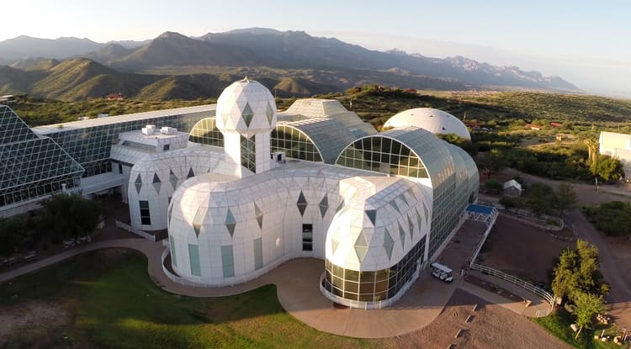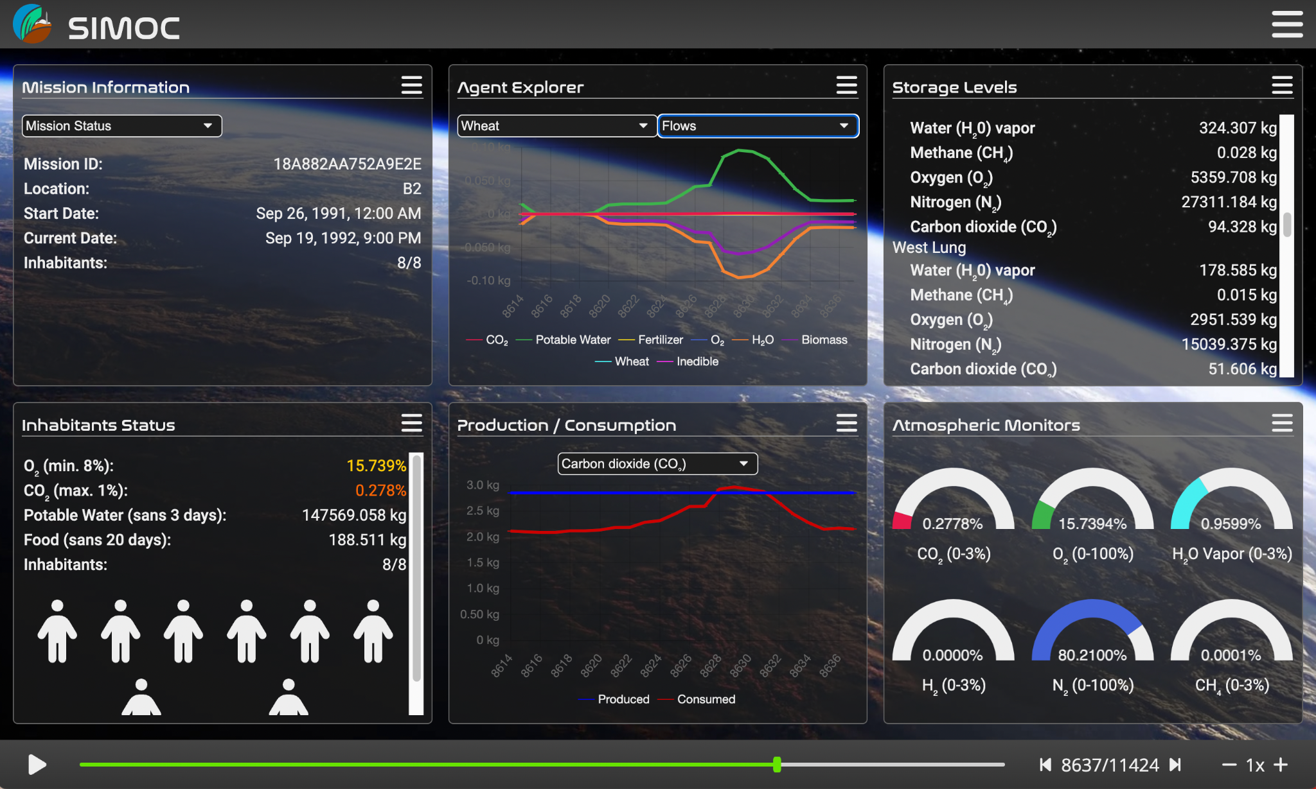

Teacher Guide
WHAT STUDENTS DO: Use the SIMOC model to study and conduct experiments on the Biosphere 2 internal ecosystem.

Students use a free online simulation model to investigate the food, carbon, and water cycles inside Biosphere 2 and design and test ways to optimize them. They will actively engage in data analysis, computational thinking, and iterative innovation through collaboration and persistence.

NGSS CORE & COMPONENT QUESTIONS | INSTRUCTIONAL OBJECTIVES
How (and why) do organisms interact with their environment and what are the effects of these interactions? LS2: Ecosystems: Interactions, Energy and Dynamics.  How do organisms interact with the living and nonliving environments to obtain matter and energy? LS2.A: Interdependent Relationships in Ecosystems  How do matter and energy move through an ecosystem? LS2.B: Cycles of Matter and Energy Transfer in Ecosystems  What happens to ecosystems when the environment changes? LS2.C: Ecosystem Dynamics, Functions and Resilience | Students will be able to:  IO1: Explore and interpret data using computer models to describe and predict the interdependence of biotic and abiotic components of an ecosystem.
How do engineers solve problems? ETS1: Engineering Design  What is a design for? What are the criteria and constraints of a successful solution? ETS1.A: Defining and Delimiting the Engineering Problem  What is the process for developing potential design solutions? ETS1.B: Developing Possible Solutions  How can various design solutions be compared and improved? ETS1.C: Optimizing the Design Solution | Students will be able to:  IO2: Use and modify a model limited by criteria and constraints to solve a complex science and engineering problem

1.0 Materials | Teacher Guide

The labels [5-8] and [9-14] throughout this document designate level-specific content: Grades 5-8, and Grades 9-14. At the teacher’s discretion, students could complete both, or assigned per-student based on ability.

Lesson Outline
Activity | Time (m) | Tasks
- Designing a Biosphere | 15-30 | Biosphere 2; Engineering criteria and constraints
- Identify the Problem | 15-30 | SIMOC; O₂ and CO₂ in Mission 1a; find main problem
(C) Research the Problem | 30-60 | Analyze O₂ and CO₂ activity by agent
(D) Develop Solutions | 15-30 | Brainstorm solutions; reason about impacts
(E) Evaluate Solutions | 30-60 | Reconfigure SIMOC; describe results
(F) Communicate the Solution | 30-60 | [5-8] Draw a diagram of carbon cycles in Biosphere 2  [9-14] Write up your experiment
(G) Reflection | 5-10 | Engineering design process, crosscut, climate/space

Estimated Lesson Time: 3-5 hours

Required Materials
- Internet-connected laptop or desktop computer. One per group.
- Printed Student Guide (7 pages). One per student.
- Chart Drawing Supplies [5-8], e.g. pencil, ruler, colored markers

Supplemental Resources
- Extension [5-8] Investigate the water cycle in Biosphere 2. (1/student)
- Extension [9-14] Read a Primary Source: Oxygen Loss in Biosphere 2. (1/student)
  - Article (1/student): https://agupubs.onlinelibrary.wiley.com/doi/pdf/10.1029/94EO00285
- Biosphere 2 Virtual Tour: https://education.azpm.org/biosphere2/
- Biosphere 2 YouTube Channel: https://www.youtube.com/@b2scienceorg esp About Our Biomes
- Biosphere 2 Documentary: Spaceship Earth: http://imdb.com/title/tt11394188/ grade 9 and above.
- Biosphere 2 online references (in Student Guide)
  - Wikipedia, esp the first 4 sections https://en.wikipedia.org/wiki/Biosphere_2
  - Reading, esp 5-11 https://teachersinstitute.yale.edu/curriculum/units/1992/5/92.05.05
- SIMOC Introduction Video, documentation, blog, etc.: https://simoc.space/
- SIMOC-B2 User Guide: see SIMOC website
- SIMOC Python API (advanced): https://simoc.space/docs/user_guide/api/getting-started.html

2.0 Vocabulary | Teacher Guide

Engineering | a field in which humans solve problems that arise from a human need or desire by relying on their knowledge of science, technology, engineering design, and mathematics (derived from NRC Framework, 2012).
Criteria | A standard list of “rules” established so judgment or decisions are based on objective and defined ideas rather than subjective ones.
Constraints | limits placed on your mission by the budget, hardware, available volume or mass, life support requirements, etc. necessary to accomplish the mission.
Data | facts, statistics, or information.
Empirical Evidence | knowledge gained through direct or indirect observation.
Observations | specific details recorded to describe an object or phenomenon.
Explanations | logical descriptions applying scientific information
Systems | a system is an organized group of related objects or components that form a whole. Systems can consist, for example, of organisms, machines, fundamental particles, galaxies, ideas, and numbers. Systems have boundaries, components, resources, flow, and feedback. (National Science Education Standards)
Sub-System | a component of a system that is itself a system.
Models | a physical, conceptual, or mathematical representation of a real phenomenon. Scientific models are used to explain and predict the behavior of real phenomena.
Agent | a virtual entity that is programmed to act according to a set of predefined rules and behaviors within an Agent Based Model. Agents are used to simulate the actions and interactions of individuals or groups within a complex system, and can be used to explore and predict the behavior of the system under different conditions.
Simulation | a virtual model of a real-world system, process, or environment to study its behavior, analyze its performance, or predict its outcomes under different conditions. It involves using computer programs or mathematical models to replicate the behavior of the system, process, or environment in a controlled and systematic manner.
Biosphere | the part of the Earth's surface, including the air, water, and land, that is inhabited by living organisms. This includes all forms of life, from microorganisms to plants and animals.

3.0 Procedures | Teacher Guide

Introduction
Biosphere 2 (B2) is a massive, sealed environment built in the early 1990s near Tucson, Arizona that housed a half acre farm, rainforest, savanna, ocean, marsh, and desert. In two different missions, Mission 1 from November 1991 to November 1993, and Mission 2 from March 1994 to October 1994, researchers lived inside the sealed habitat, growing all their own food and maintaining the internal living (biotic) and non-living (abiotic) systems that kept them alive. They learned many valuable lessons about the complex interactions between the subsystems that make up Earth's ecosystems, including how the microbiome can impact the balance of oxygen and carbon dioxide, and how the human-built environment can have long-lasting effects on the breathable atmosphere.

SIMOC, the Scalable, Interactive Model of an Off-world Community, is built upon authentic data from decades of research in mechanical and biological life support systems. It is composed of a web-based interface to a powerful computational engine, providing a platform for both research and education. Users select from a list of available subsystems to create their own model habitat and then run a simulation of how that model functions over time. Originally built to model Mars habitats, SIMOC now supports simulations of Biosphere 2, with new agents and configurations that use authentic data from scientific studies.

The lesson revolves around an incident that happened with oxygen (O₂) and carbon dioxide (CO₂) levels in Mission 1. During the second winter (January ‘93), oxygen levels fell so low that the medical team decided to inject supplemental oxygen into the B2 atmosphere. This was despite nearly a decade and millions of dollars spent planning. Research published in the following years found that design calculations were wrong about two particular processes:
- Soil Respiration. Several thousand tons of rich, organic soil were transplanted into the B2 greenhouse and biomes. Microorganisms in the soil consumed more O₂ and produced more CO₂ than expected.
- Concrete Carbonation. Concrete consumes CO₂ from the air as it ages through the process of carbonation. When the levels of CO₂ in the air are high, this rate is much faster. Inside B2, concentration of CO₂ was maintained around 0.025% or 2,500 parts per million (ppm), as compared to earth’s typical 350 ppm. This caused the concrete to absorb much more CO₂ than expected.

How was this discovery made? The combined effect of these two processes was that O₂ levels went down, and CO₂ levels stayed the same (production/consumption are balanced). So it seemed at first like some process was just consuming extra O₂. Then, when high rates of carbonation were found in concrete samples, it became clear that some process was consuming extra O₂ and producing CO₂ (i.e. respiration), but the extra CO₂ was then absorbed by the concrete, so it hadn’t been noticed. The goal is to recreate this discovery using a simulation of Mission 1, and then engineer a new configuration of B2 to improve the outcome.

To gain a better understanding of SIMOC and Biosphere 2, skim through the Supplemental Resources above. Before the lesson, go through activities B, C, D and E in the Student Guide and follow-along with SIMOC at https://ngs.simoc.space.

The activities of this lesson correspond to the stages of the Engineering Design Process, and to steps of the 5E Instructional Model.

The Engineering Design Process
Students engage in a data analysis and engineering design activity using SIMOC. They will use the engineering design process to solve a real-life problem with direct applications to climate change and long-term space habitation. A brief description of the engineering design process can be seen in this diagram. A more detailed description is in Activity (G) in the Student Guide.

Engineering Design Process
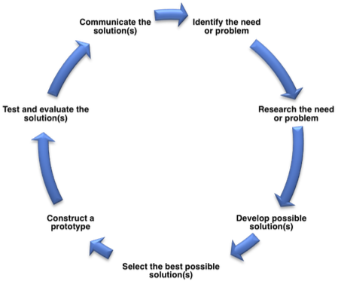

The 5 E’s of Inquiry-Based Learning
The 5E instructional model is a framework for teaching that promotes student-centered learning through an iterative process of engagement, exploration, explanation, elaboration, and evaluation. It encourages students to actively construct their own understanding of concepts and fosters a deeper, more meaningful learning experience.

- Engage: Spark curiosity with a captivating introduction.
- Explore: Encourage investigation and experimentation to deepen understanding.
- Explain: Clarify concepts and provide context to solidify comprehension.
- Elaborate: Encourage application of knowledge and extension of learning.
- Evaluate: Assess understanding and adjust instruction as needed to support student growth.

3.0 Procedures | Teacher Guide

The lesson is divided into 7 activities, Activity (A) - Activity (G). The Student Guide consists of a 1-page worksheet for each activity. An optional Extension activity/worksheet is included, which students can complete on their own using a computer. This can be assigned to fast finishers and/or as homework.

Answers and feedback for each activity is colored green.

Preparing to use SIMOC
Students are unlikely to be ready to begin using SIMOC without some preparation. A series of activities has been designed to prepare students to engage in authentic science using SIMOC. These activities provide a scaffold to support student understanding of the key variables that can be controlled with SIMOC. The activities help students identify key aspects of an environment that can sustain human life. These activities are organized by the phases of the engineering design process to make this process more overt. The activities are also organized by the 5E Instructional Model.

📒Teacher Tip: For detailed instructions on how to use the SIMOC web application, see Section (I) SIMOC User Guide.

(A) Designing a Biosphere | Engage | Teacher Guide

Step 1: Read the section ‘What is a biosphere?’ and ‘Engineering Criteria and Constraints’.

Step 2: Introduce Biosphere 2. The Student Guide includes minimal background on Biosphere 2, but it is in fact a fascinating and engaging topic on its own. Refer to the Supplement Materials above for resources on Biosphere for before, during and after the lesson.

📒Teacher Tip: A very effective and dramatic way to introduce Step 3 is to get the class quiet and then loudly and firmly close the door. Then tell them they have just been sealed inside B2, and nothing can get in or out and they must survive for 2 years.

Step 3: Brainstorm engineering constraints of building an artificial biosphere. Links to online sources are provided in the Student Guide (A) Designing a Biospheres, and students are prompted to look up additional sources. Remind students to evaluate the credibility of each source (use Student Guide (H) Credible Sources Evaluation).

📒Teacher Tip: The ‘think, pair and share’ method may work better than simple brainstorming at this step. Some teachers post large pads of paper or Post-It notes around the room with headers, and have students walk around to each one and contribute. Students might also be encouraged to enumerate and draw what they already know about the carbon, water and nitrogen cycles. Besides identifying different constraints, ensure that students understand the impact of not meeting these constraints on humans, plants, etc.

Some examples of constraints and solutions they might identify are given in the table below:

Constraint | Engineering Solution
Provide oxygen and remove carbon dioxide from the air | Plants on the farm and in the biomes recycle the air by photosynthesis
Provide clean water | Water recycling system, dehumidifier
Provide food for crew | Grow crops and raise animals
Recycle human, animal and plant waste | Process and compost
Provide nutrients for the plants | Bring in rich, organic soil from outside.

(B) Identify the Problem | Explore | Teacher Guide

Step 1: Read Section: Identify the Problem

Step 2: Login to SIMOC and navigate to the Mission 1a Dashboard. Instructions in Student Guide.

📒Teacher Tip: At this stage, students should explore the Preset configuration Mission 1a, which is a pre-calculated simulation that take 10-20 seconds to load entirely. After clicking ‘Launch Simulation’, you should see a pop-up that says ‘Downloading simulation data…’. If any changes are made on the configuration screen (besides the Preset), a ‘custom’ simulation will be created and calculated, which can take up to 5 minutes to fully load. To keep things moving, students should wait until Activity E (Evaluate solution) to generate their first custom simulation, after careful consideration of the changes they’re making.

Step 3: Investigate the oxygen (O₂) and carbon dioxide (CO₂) levels inside B2 throughout Mission 1a.
- Q1: Students are instructed to create a chart by plotting various points throughout the simulation, then connecting them into a line. A complete chart of O₂ and CO₂ levels throughout the full mission can be found via the following method, which is not described in the Student Guide. You might let them follow the instructions and possibly discover this method, then use it during feedback:
  - Open an Agent Explorer panel. See instruction panel in Student Guide (C)
  - Navigate to ‘Greenhouse B2’, Storage’
  - In the panel menu, select ‘Maximize Panel’ and wait for the data to load (might be slow).
  - Hide all lines except the target resource by clicking on the legend.
- Q2: Alternatively, students can plot O₂ or CO₂ thresholds from other sources.
- Q4: Example answer: Oxygen goes down; slow at first, then faster. Carbon dioxide goes way up immediately, fluctuates a lot, and goes up even more at the end.
- Q5: The most important problem is that the habitat is running out of oxygen. The CO₂ is also high, but that’s intentional (see ‘CO₂ Management’ in Configuration) and it’s generally stable.

📒Teacher Tip: The graphs of O₂ and CO₂ are referenced throughout the lesson. It may be useful to keep them up throughout the lesson, e.g. on a whiteboard, and have each group draw a line for their best results over it at the end.

(C) Research the Problem | Explain | Teacher Guide

Step 1: Write 1 description for each ‘box’, e.g. ‘Plants’. They should identify the underlying processes (respiration, photosynthesis, carbonation), describe how it changes over time, and describe any ways it responds to the environment.

Step 2: Fill-in the O₂ and CO₂ columns for each ‘line’, e.g. ‘Wheat’. Plants and Concrete vary a lot throughout the simulation, so it may be difficult to find the absolute highest value. You could make this competitive, and require students to give the step number where they got that value. Intuitively, plants should be highest on the day before they’re harvested, in the hottest part of the day, in the sunniest month of the year. Concrete should be highest earlier in the simulation when ambient CO₂ is high and carbonation rate is low.

They don’t necessarily need to look up every single plant and biome, but they should at least notice that different plants and biomes are unequal, and try to reason about why. Plants have different growth and production rates, and also the growing conditions and B2 affect plants differently. For example Wheat is highly productive, but needs a lot more light. Biomes have different mixes of photosynthesis (from vegetation) and respiration (from soil). Most are net-respiration, but desert is net-photosynthesis.

Name | O₂ | CO₂ | Description
Human | 0.297 | -0.360 | - Human respiration.  - The same every hour (flat).  Teacher Notes  - In reality, fluctuates throughout the day based on activity level
Plants  - Rice  - Wheat  - Sorghum  - Peanut  - Corn  - Dry Bean  - Sweet Potato  - Vegetables  - Soybean  - Orchard | -0.589  -0.125  -0.088  -0.192  -0.164  -0.198  -0.414  -0.125  -0.106  -0.507 | 0.810  0.171  0.121  0.264  0.226  0.273  0.568  0.172  0.146  0.697 | - Photosynthesis.  - Based on age/size of the plant: older/bigger plants do more  - Based on sunlight  Teacher Notes  - The age-related change in flows is calculated using the ‘growth_rate’ (visible in the ‘Growth’ panel of the agent explorer).  - Sunlight (PAR) comes from the B2 Sun agent, which has a daily cycle (highest at mid-day) and a yearly cycle (higher in summers, lower in winters).
Biomes  - Greenhouse  - Rainforest  - Desert  - Savannah | 0.337  0.190  -0.046  0.223 | -0.928  -0.524  0.128  -0.614 | - Soil respiration and Plant Photosynthesis  - The same every hour (flat)  Teacher Notes  - Each biome has a specific rate of soil respiration and plant photosynthesis, taken from research (for greenhouse, plants are excluded as they’re accounted for above). Flows (to left) are the combined effect of these. All biomes are net-respirators (at different rates), except for desert.
Concrete |  | 1.698 | - Carbonation  - Starts low and increases ~10x quickly, then fluctuates +- 10%.  Teacher Notes  - Rate is based on the CO₂ concentration in the air, and (to a lesser extent) how much carbonation has already occurred.
CO₂ Removal SAWD |  | 0.425 | - Electrically removes CO₂ from the air.  - Activates after CO₂ > CO₂ Upper Limit (2500 ppm, 0.025%).  Teacher Notes  - In reality, electric fans blow air over a sorbent (CO₂-absorbing substance).  - Activation has an 8-step buffer (delay).

[9-14] In addition to, or instead of the maximum hourly value, estimate the mean hourly values for each agent/line above. For humans, values are flat so mean is equal to maximum. For plants, students could estimate visually from the charts. Technically, the mean should be approximately (0.25 * maximum). Intuitively, the average each day is about half of the maximum, and the average across is also half the maximum. Added together, the average is ¼ of the daily/lifetime maximum. For other agents, estimate visually.

(D) Develop Solutions | Elaborate | Teacher Guide

Step 1: Look at Mission 1b in SIMOC.
- Q1: Matches end of Mission 1a: atmosphere (low O₂, high CO₂), concrete (carbonation rate). Has O₂ reserves, and more sweet potato, dry bean and red beet.
- Q2: O₂ rises quickly, then falls (more slowly than M1a). CO₂ fluctuates, trends down slightly.

Step 2: Propose changes in the design of the habitat to improve the simulation results, and explain the
expected first- and second-order impacts of those changes on overall O₂ and CO₂. The number of changes each group makes will depend on ability; several possible answers are given below.

[9-14] Tell students to estimate a first-order impact on O₂ and CO₂ of in kg and %, based on the mean values you observed in Activity (C).
Change to Configuration | Estimated Impact | Second-Order Impacts
Increase the area of sweet potato plants to 400. | Consume more CO₂, make more food than other plants | SAWD will remove less CO₂
Change the start date to.. | Mission 1a includes 2 winters. Changing start-date to summer will increase average sunlight. | Plants produce more food, recycle more air via photosynthesis.
Reduce the area of rainforest or savannah, increase the area of desert to.. | Consume less CO₂ and produce more oxygen. | O₂ levels will go down more slowly
Reduce the number of Inhabitants to.. | Reduces O₂ consumption slightly, require less food | Changes from decreasing the number of plants.
Increase the starting carbonation of the concrete to.. | Consume less CO₂ | SAWD will have to remove more CO₂, or levels will rise
Increase the CO₂ Upper Limit, add CO₂ reserves of.. | (up to 0.3%) Concrete will carbonate at a faster rate | Consume more CO₂ (stabilizing)
Add O₂ reserves of.. | Can keep rates high artificially | O₂ levels are no longer a constraint on photosynthesizers, so can increase plants/biomes.

📒Teacher Tip: When considering how to ‘improve’ the results, encourage students to consider the full range of constraints, not only O₂ and CO₂. They might also try to minimize electricity consumption, or provide a more balanced diet, etc.

(E) Evaluate Solutions | Evaluate | Teacher Guide

Step 1: Configure a custom simulation in SIMOC, starting from the Mission 1a preset, with the changes proposed in (D).

📒Teacher Tip: SIMOC generates custom simulations using a cloud backend, because it’s too resource-intensive to run in a web browser. We’re still growing, so sometimes it can be slow or get interrupted.
- If it happens while the simulation is loading, you’ll need to start over.
- At any time, you can download the current data (using the Dashboard menu), and re-load it into SIMOC from the Main Menu. Recommend that students do this after their custom simulations are fully loaded.

Step 2: Answer questions, re-draw the charts. Answers will vary, but students should focus on giving concise and precise descriptions of the most interesting or relevant results.

Step 3: Continue to iterate on your configuration to improve outcomes. Here you may refer students to the Engineering Design Process in Activity (G) as a guide for the iteration and improvement process.

Extension
If students have computer programming skills, the .json file downloaded from SIMOC can be inspected manually, for example using matplotlib and Python. The SIMOC GitHub repository includes Python functions for generating charts from the data. For details, Refer to the SIMOC Python API in the Supplemental Resources section.

(F) Communicate the Solution | Teacher Guide

[5-8] Students create a diagram of the carbon cycle inside Biosphere 2 and compare them to the carbon cycle on Earth. The Student Guide provides a 6-step design process for designing a layout. Alternatively, students can create posters or a presentation on the computer with their group.

[9-14] Students write an experiment report, following the academic style: Introduction, Methods, Results, Discussion, and Conclusion. Encourage them to include hand-drawn charts and/or screenshots from SIMOC to illustrate their results. The research paper on which this lesson is based, Oxygen Loss in Biosphere 2, is included as an Extension exercise. This can be used as a reference for writing style, formatting, and (because it’s essentially the same experiment) how to present the results. Most students will not understand some portions of the study, but all should be able to answer the questions given. The details could be discussed in groups, or diagramed using the same process as the [5-8] Activity (F).

(G) Reflection | Teacher Guide

Students reflect on their work by reading and writing on various engineering and design frameworks. Besides those included, below are two templates which teacher have found useful when using SIMOC:

- NASA: Design Engineering Process
- Engineering Design Process Flow Chart

4.0 Evaluation / Assessment | Teacher Guide

Example answers to questions in the Student Guide are provided throughout this document. In addition, formative assessment rubrics are provided for each stage of the activity, as well as a summative assessment for final activity.

Extension | Teacher Guide

Two extension activities are included for use at teacher’s discretion.

[5-8] Follow the same procedure as (C) and (F) with the water cycle.
Name | Potable | H2O | Treated | Urine | Description
Human | 1.097 | -1.027 |  | -0.487 | - Drink water (potable). Some is exhaled/perspirated (h2o). The rest is urinated, along with some moisture from solid food.  - The same every hour (flat)  - In reality, this fluctuates for several reasons.
Plants  - Rice  - Wheat  - Sorghum  - Peanut  - Corn  - Dry Bean  - Sweet Potato  - Vegetables  - Soybean  - Orchard | 59.964  12.670  8.938  94.243  16.711  97.320  25.493  25.168  52.180  84.318 | -59.693  -12.613  -8.897  -94.188  -16.635  -97.263  -25.299  -25.113  -52.149  -84.-95 |  |  | - Transpiration  - Absorb potable through roots, evaporate h2o from leaves; a small amount is used to create new biomass.  - Based on age/size of plant and sunlight (see Carbon Cycle key)
Dehumidifier |  | 200 | -200 |  | - Electrically removes water vapor from the air, converts it to treated water.
Urine Recycling Processor VCD |  |  | -1.96 | 2.0 | - Electrically separates urine to treatable water and waste.
Multifiltration Purifier Post Treatment | -237.5 | - | 237.5 |  | - Electrically converts treated water into potable water

[9-14] Read a scientific paper and answer the questions about it. May also be used as a reference for Activity (F) Communicate the Solution.
- Q1: “O₂ in Biosphere 2 decreased during the first 16 months of closure from the ambient 21% to 14%, enough to cause health problems in the human occupants.”
- Q2: “...an obvious hypothesis for the O₂ loss is that photosynthesis … has not kept up with respiration…”
- Q3: Page 2, paragraph 2 (summarizing): Concrete core samples were taken inside and outside of biosphere 2. Chips were analyzed at different depths to see how much carbonation had occurred.
- Q4: LIkely between 550 (Table 1) and 750 (Table) kmoles. CO₂ is 44 grams per mole, so 44 kg per kmole. That means the concrete absorbed 24-33 tons of CO₂.
- Q5: No, because the process of creating and pouring concrete creates more CO₂ than it absorbs.
- Q6: Either way could be argued. Painted would make the experiment more reliable and leave more CO₂ for the plants, but unpainted absorbs the actual excess in CO₂ they experienced.
- Q7: Answers may vary. Our advice is: be skeptical when trying to apply simulations to real life.

Student Guide

(A) Designing a Biosphere

What is a biosphere?
A biosphere is a self-sustaining ecosystem that can support life over an extended period of time. The term comes from the combination of two words: "bio," meaning life, and "sphere," meaning a closed system. In a biosphere, all of the necessary elements for life are present and can be recycled indefinitely. This includes air, water, and nutrients for plant growth, as well as the organisms themselves that make up the ecosystem. Biospheres are complex systems, and require careful management and balance to remain self-sustaining over time.

Engineering Criteria and Constraints
In the world of engineering, every project has criteria and constraints that must be considered when designing and building a system. Criteria are the requirements that the system must meet in order to be successful, while constraints are the limitations that the design must work within. For example, a criteria might be that a bridge must be able to withstand a certain weight limit, while a constraint might be the budget that the project has to work with.

Biosphere 2
Biosphere 2 (B2) is a massive, air-tight facility in the Arizona desert, built to be an artificial, closed ecosystem. It was named "Biosphere 2" because it was meant to be the second fully self-sufficient biosphere, after the Earth itself ("Biosphere 1"). It also included several ecosystems, including a rainforest, ocean, desert, savannah and farm. These help support humans, but also require maintenance.

The engineering criteria for Biosphere 2 was to support a crew of 8 inhabitants for 2 years. What were the constraints involved in building Biosphere 2?
- Brainstorm constraints for column 1 of the table below. Think of the things humans require to live. Then think of what those things require.
- Do your own research to add additional constraints. Below are 2 good sources. For others, use the Credible Resources Evaluation to determine whether you can trust it or not.
  - https://en.wikipedia.org/wiki/Biosphere_2: The first 4 sections (stop at ‘First Mission’)
  - https://teachersinstitute.yale.edu/curriculum/units/1992/5/92.05.05: Sections 5-11 (1993)
Constraint | Engineering Solution
Maintain temperature of 70-85°F | Computer-controlled heating and cooling system

Student Guide

(B) Identify the Problem
On September 26, 1991, a team of 8 researchers stepped into B2 and sealed the door behind them. At that moment, the B2 ecosystem was cut off from Earth’s ecosystem, and would stay cut off for 2 years. They used hundreds of sensors to measure things like the level of oxygen (O₂), water vapor (H₂O) and carbon dioxide (CO₂) in the atmosphere, how much light the crops got, and how much food the crops produced. After the experiments, all that data was collected and analyzed for scientific studies.

One way of studying complex systems like B2 is to use simulations. Engineers make computer models of individual sub-systems, like the humans and plants, and try to re-create the results of a real-life experiment - like the one at B2. Then, some parameters can be adjusted, like how many of each plant are grown, and the impact of the simulation can help predict impacts of the real-life system.

You’re going to use a simulation software called SIMOC to do just that. First, you’ll look at a simulation of the first 475 days of Mission 1, or ‘Mission 1a’. Follow the instructions below to get started:
- Go to ngs.SIMOC.space; login, create an account, or continue as a guest.
- On the main menu, click ‘Biosphere 2’ to go to the Configuration screen.
- On the Configuration screen, the Preset ‘Mission 1a’ should be selected by default. Click ‘Launch Simulation’ to go to the Dashboard.
- On the Dashboard, use the control bar on the bottom to scroll forward and backward through the simulation. Find the information you need to answer the questions below.

Questions
1. Find the CO₂ and O₂ level in the Atmospheric Monitor. Scroll through the simulation and look at how it changes over time. Then, draw Oxygen and Carbon Dioxide charts to the right.  2. On the ‘Inhabitant Status’ panel, hover over the O₂ and CO₂ labels to see the different health thresholds for humans. Draw these onto the charts as horizontal lines. Use a different color or line style (dots, dashes...).  3. Add a legend to the charts.  4. Describe with words how the CO₂ and O₂ levels change over time. (e.g. ‘CO₂ goes down quickly, then stays the same’)  5. What is the most important problem facing the crew at the end of Mission 1a? | 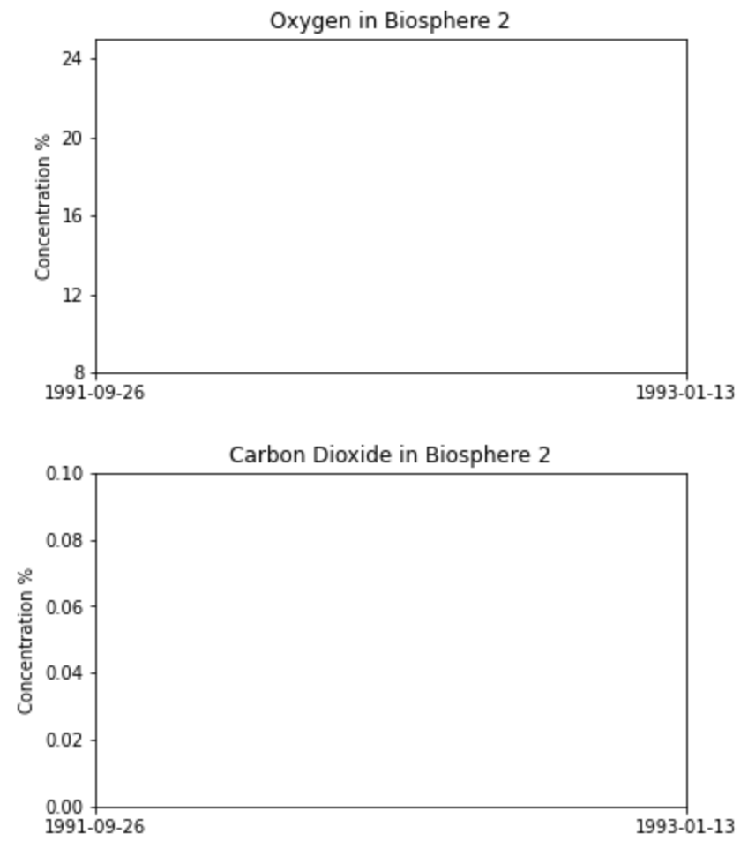

Student Guide

(C) Research the Problem

SIMOC Agent Explorer
From any Dashboard panel, click the menu icon and change to the ‘Agent Explorer’ panel. Use the left drop-down menu to change agents, and the right one to select different categories:
- Flows. Resource exchanges between two different agents. If the number is positive, it means the agent is a Consumer. If it’s negative, they’re a Producer.
- Deprive. Certain agents die when they don’t get enough resources, like humans with oxygen, water or food. These values show how much longer they could live without that resource.
- Storage. This is the amount of some resource an agent currently has.
- Growth. Some agents’ flows change over time. These values are all the factors that affect what the current flows are.

Your final project will be to reconfiguration Mission 1a to improve the outcome. The first step is to understand the ‘agents’ in the SIMOC model and how they factor into the problem you identified above.
- Go back to the Configuration screen. Click each category on the left (e.g. ‘Preset’), and read the reference text on the right. In the ‘Description’ column below, take notes on how each agent changes over time and responds to the environment.
- Go to the Dashboard screen again (make sure Preset ‘Mission 1a’ is selected, and click Launch Simulation). Using the Agent Explorer panel (instructions below), find and record the maximum hourly flow of O₂ and CO₂ for each agent in the table below.

Agent | O₂ | CO₂ | Description
Human

Plants
- Rice
- Wheat
- Sorghum
- Peanut
- Corn
- Dry Bean
- Sweet Potato
- Vegetables
- Soybean
- Orchard
Biomes
- Greenhouse
- Rainforest
- Desert
- Savannah
Concrete

CO₂ Removal SAWD

Student Guide

(D) Develop Solutions
On January 12, 1993, 475 days into Mission 1, the medical team decided to inject extra oxygen from refrigerated trucks into the Biosphere 2 atmosphere. The SIMOC Preset ‘Mission 1b’ is the remaining 257 days of Mission 1. It picks up at the end of Mission 1a with some changes.

- On the Configuration screen, read about Mission 1b in the ‘Presets’ reference, and look at the plant areas in ‘Plant Species’. What changes are made to the configuration in Mission 1b?

- Click ‘Launch Simulation’, look through the O₂ and CO₂ in Mission 1b, describe what happens.

Using what you’ve learned about how agents behave and the changes made in Mission 1b, now you’re going to reconfigure Mission 1a to improve the outcome. For each change in the configuration, write a hypothesis statement, following the ‘If, Then, Because’ structure.

- In column 1, brainstorm different ways you could improve any of the constraints identified earlier. These should be specific changes to the configuration of SIMOC.
- In column 2, predict the effect it will have the overall impact on O₂ and CO₂ levels. These should be specific changes to flows in kg/h, or overall O₂ and CO₂ levels (%, ppm). Later, you’ll compare your estimates to the actual impact.
- In column 3, predict the second-order, or ‘downstream’ effects of each change: how will other agents respond to the changes you made? How will the whole system respond?

Change to Configuration | Estimated Impact | Second-Order Impacts
Increase the area of sweet potato plants. | If more sweet potatoes are added, then more CO₂ will be consumed and food produced because sweet potatoes are more productive than other plants. | If more sweet potatoes are added, then SAWD will remove less CO₂ because more will be absorbed by the plants through photosynthesis.

Student Guide

(E) Evaluate Solutions
Implement your solutions to Mission 1a and compare your simulated results to the actual.

On the Configuration screen, make sure the ‘Mission 1a’ Preset is selected. Make your change(s) to the configuration. Click ‘Launch Simulation’ and wait for all the steps to be sent. (This might take up to 5 minutes).

Questions
1. Draw the CO₂ and O₂ from your simulation onto the charts, like you did before.

2. Copy the lines from your old charts onto these ones in a different color or style, and add a legend.

3. Describe how your results are different from the actual Mission 1a.

4. Choose 3 agents to analyze in the table below. Fill-in the maximum hourly O₂ and CO₂ from your simulation below, and look at their behavior over time. Then answer the question in column 4.

Agent | O₂ | CO₂ | How did it change in your simulation?

5. Look back at the constraints you listed in Activity A. Does your simulation meet all the constraints?

6. If you have time, test other configurations and add them to the Oxygen and Carbon Dioxide charts. Make sure to record all of the changes you make to the configuration.

Student Guide

(F) Communicate the Solution [5-8]
You’re going to create a diagram of the carbon cycle at Biosphere 2 using data from the table. Use the design process below:
- Look at a few examples by searching ‘carbon cycle’ in Google images.
- Think about how you will represent each agent. A picture? A label? Both?
- Think about how you will represent flows. Lines? Arrows?
- Think about how you will organize agents on the page. You could put producers on left and consumers on the right, or you could try to copy the layout of Biosphere 2, or..?
- Draw a quick, small mockup of the diagram. Then try to see it through a stranger’s eyes: Can you see a ‘cycle’? Can you see the difference between O₂ and CO₂ flows? Draw 2 more mockups with small changes.
- Choose the best design, and draw your final diagram.
- How does this compare to the carbon cycle on Earth? Add notes to your diagram to point out the key differences.

Mock-ups

Final

Student Guide

(F) Communicate the Solution [9-14]
In this final activity, you will report on the results of your experiment and draw conclusions based on your data. Scientific writing is an important skill for communicating scientific findings, and this activity will provide you with an opportunity to practice this skill.

Write a scientific report that includes an introduction, methods, results, discussion, and conclusion sections. In your report, describe the experimental design, including any variables that were tested, the methods used to collect data, and the results obtained. Analyze your data, including any patterns or trends that you observed. Discuss your findings in the context of your experimental design and the relevant scientific concepts.

Guide to Scientific Writing
Scientific papers usually follow a specific format, which mirrors the scientific inquiry process. Organize your paper into 5 sections with the headings and content below:
Introduction | Provide background information about the problem you are addressing and explain the purpose of your experiment. State your hypothesis and briefly describe your experimental design.
Methods | Describe your experimental design, including any variables that were tested, how you collected data, and any equipment or materials used. Provide enough detail so that someone else could replicate your experiment.
Results | Present your data in tables or graphs and describe any patterns or trends that you observed. Explain any statistical analyses that you performed and include the values obtained.
Discussion | Interpret your results and discuss the implications of your findings. Compare your results to other research in the field and explain any discrepancies or similarities.
Conclusion | In this section, summarize your findings and explain how they support or refute your hypothesis. Discuss any limitations of your study and suggest future research directions.
Remember to use clear and concise language, avoid personal pronouns, and cite any sources used in your report. Use appropriate scientific terminology and be specific in your descriptions.

Student Guide

(G) Reflection
The Engineering Design Cycle
Working with your group, discuss and identify where you participated in each part of the Engineering Design Cycle.  1. Write the event, problem, need, solution, test, etc. your team participated in next to the appropriate section of the cycle. Include arrows between steps of your team needed to go back (iteration) during the planning to test a new solution. There should be at least one example next to each step above. | Identify the need or problem  - Specify and prioritize requirements and constraints to better define the need or problem  Research the need or problem  - Examine current state of the issue and current solutions  - Explore other options through resources (Ex: Internet, interviews, periodicals, etc.)  - Identify the constraints  Develop possible solution(s)  - Brainstorm possible solutions  - Draw on mathematics and science  - Explain or describe the possible solutions on paper, computer simulation, or 3D model  - Refine the possible solutions  Select the best possible solution(s)  - Determine, using simple analysis, which solution(s) best meet(s) the original requirements  Construct a prototype  - Model the selected solution(s) on paper, computer simulation, or 3D model  Test and evaluate the solution(s)  - Does it work?  - Does it meet the original design constraints?  Communicate the solution(s)  - Make an engineering presentation that includes a discussion of how the solution(s) best meet(s) the needs of the initial problem, opportunity, or need  - Discuss societal impact and tradeoffs of the solution(s)

Student Guide

Your Experiment
- What were the starting conditions?

- Did it work?

- What did not work?

- What did you do when things didn’t work out like you expected?

- If given enough time, what would your next step look like?

About Your Thinking
- What were some of the struggles you and your team went through during the project?

- What was surprising to you about the engineering cycle?

- What do you think you have learned from this process that you didn’t know before?

Student Guide

Reflection on Engineering Practices
When scientists study phenomena to better understand how the natural world works or when engineers design solutions to a problem, they engage in certain processes called practices. These practices are, essentially, how science or engineering is done. They are listed in the table below.

In your group, reflect carefully on the activities you have just completed and answer the following questions using the table.
- What Science and/or Engineering Problem did you do?
- When? During which activities?
- Explain your reasoning for your claim.

Practice | When? | What is your reasoning?
Asking questions and defining problems

Developing and using models

Planning and carrying out investigations

Analyzing and Interpreting data

Using mathematics and computational thinking

Constructing explanations or designing solutions

Engaging in argument from envidence

Obtaining, evaluating and communicating information

Student Guide

Reflection on Crosscutting Concepts
When scientists study phenomena to better understand how the natural world works or when engineers design solutions to a problem, they use concepts that are important in all science and engineering problems. These crosscutting concepts provide insight into new problems. These Crosscutting Concepts are listed in the table below.

In your group, reflect carefully on the activities you have just completed and answer the following questions using the table.
- What Crosscutting Concepts were important to you?
- When? During which activities?
- Explain your reasoning for your claim.

Practice | When? | What is your reasoning?
Patterns

Cause and effect: Mechanism and explanation

Scale, proportion, and quantity

Systems and system models

Energy and matter: Flow, cycles, and conversation

Structure and function

Stability and change

Student Guide

(H) Credible Sources Evaluation

Instructions: Use the following to identify Credible Sources for your research.

What’s the difference between a primary source and a secondary source? For science research, primary sources are original materials not filtered or interpreted by another person or organization. Examples include papers, dissertations, interviews, lab notebooks, study reported in a journal article, and technical reports. A secondary source provides commentary, analysis, discussion, or opinion about the primary source. Examples include review articles, blogs, opinion editorials, newspapers, and news media sources.

URL #1:
URL #2:
URL #3:

Check if Yes ✔ |  |  | Criteria for a Credible Source
Source #1 | Source #2 | Source #3
 |  |  | 1. Is the website an organization [.org], educational institution [.edu], or government [.gov] site? If not, see #2, otherwise go to #3.
 |  |  | 2. Is the website hosted by a periodical, such as a science journal or magazine that publishes science research?
 |  |  | 3. In Google, type link:// in front of the home page URL and hit enter. The number in the search result is how many times that page has been linked to as a reference or resource. Is that a big number, such as hundreds of thousands or more? If yes, see #4. Otherwise go to #5.
 |  |  | 4. Investigate the sources (URL’s) that have linked to the page. Start at the first link that is not an internal link. Are most of them considered credible sources, such as other .org, .edu, or .gov sites?
 |  |  | 5. Read the “About us” section. Is there a list of names for the contributors to the site? If yes, see #6, otherwise go to #7.
 |  |  | 6. Do a search for one of those contributors. Are you able to find information about that person and verify their experience they are advertising on the website? Does their experience match the purpose of the website?
 |  |  | 7. Do links on the page work, meaning they are unbroken?
 |  |  | 8. Is the source a primary source?
 |  |  | 9. Total Score for each resource (total # of checkmarks for each column)

Check if Yes ✔ |  |  | Criteria for a Non-Credible Source
Source #1 | Source #2 | Source #3
 |  |  | 1. Is the website a .com or .net site?
 |  |  | 2. Is the website hosted by a blog, satire site (spoof or parody sites that exaggerate truth using humor), or an opinion editorial page?
 |  |  | 3. Does the site use loaded language or biased language? (These are words that are chosen to influence the reader to react a certain way that is sympathetic to the author’s cause using emotion or stereotypes)
 |  |  | 4. Investigate the sources (URL’s) that have linked to the page. Are most of them considered credible sources?
 |  |  | 5. Is there a list of sponsors or paid for advertisements for the website? If yes, see #6, otherwise go to #7.
 |  |  | 6. Are the sponsors biased toward one opinion, goal, or cause?
 |  |  | 7. Are links broken and/or has the page not been updated recently?
 |  |  | 8. Is the source a secondary source?
 |  |  | 9. Total Score for each resource (total # of checkmarks for each column)

Now, compare the total checkmarks for each URL. For each URL, put a checkmark in either “It’s Credible”, “It Might be Credible”, or “It’s Not Credible.” You can only choose one.

URL | # of Credible Marks | # of non-Credible Marks | It’s Credible  (2 or fewer checkmarks in the non-Credible Marks column) | It might be Credible  (checkmarks are somewhat even in both columns) | It’s Not Credible  (5 or more marks in the non-Credible Marks column.
#1
#2
#3
(These resources were developed by Arizona State University’s Mars Education Program, under contract to NASA’s Jet Propulsion Laboratory, a division of the California Institute of Technology)

Student Guide

Extension: The Water Cycle at Biosphere 2 [5-8]
Analyze the water cycle, using the same process you used for the carbon cycle. Fill-in the table using the Configuration reference text to describe the behavior, then find the max hourly flows of each resource in Mission 1a using the Dashboard. SIMOC tracks 4 different types of water:
- Potable. Liquid water that’s clean enough for humans to drink.
- H2O. Water vapor, in the air.
- Treated. Liquid water that has been treated, but isn’t clean enough to drink.
- Urine. Liquid water that can be treated.

Name | Potable | H2O | Treated | Urine | Description
Human

Plants
- Wheat
- Sweet Potato
- Vegetables
- Orchard

Dehumidifier

Urine Recycling Processor VCD

Multifiltration Purifier Post Treatment

Now, create a diagram of the water cycle following the same steps you used for the carbon cycle: Look up some examples, draw a few mock-ups, then choose the best layout and draw the final.
Mock-up 1 | Final
Mock-up 2

Mock-up 3

Student Guide

Extension: A Primary Source [9-14]
These activities are based on an actual investigation published in an engineering journal in 1991 titled Oxygen Loss in Biosphere 2. You’re going to read the paper and answer the following questions.

You can find the article by searching the title in Google Scholar, or use the link below:
https://agupubs.onlinelibrary.wiley.com/doi/pdf/10.1029/94EO00285

If you don’t understand some of it, don’t worry! Try to understand enough to answer the questions, and skim the parts you don’t understand.

- What problem do the authors identify in the introduction?

- What is the ‘obvious hypothesis’ for the decline in O₂ (para 3), and what’s wrong with this hypothesis (para 3)?

- Describe the process used to measure the carbonation of the concrete.

- How many kmoles of CO₂ were absorbed from the atmosphere? How many kg of CO₂ does this represent?

Critical Thinking
- If concrete absorbs CO₂ from the air, could we use concrete to reduce the amount of CO₂ in Earth’s atmosphere?

- Importantly, it was the unpainted concrete which absorbed so much CO₂ in Biosphere 2. If you were building a biosphere on Mars and you were using a large amount of concrete for the structure, would you paint the concrete or leave it exposed? Why?

- How accurate are the values in SIMOC, when compared to the actual measurements in this paper? What are some details from the paper which aren’t part of the simulation?

(I) Assessment Rubrics
 | Exemplary | Proficient | Developing | Novice
- Designing a Biosphere | Identifies most human and plant constraints, as well as the need to balance the carbon and water cycles.  Identifies specific solutions to many constraints from multiple reputable sources. | Identifies most human and plant constraints, as well as the need to balance the ecosystem.  Identifies solutions to some constraints from multiple reputable sources. | Identifies most human constraints and some secondary constraints, such as plants or mechanical systems.  Identifies solutions to some constraints using the references provided. | Identifies some human constraints such as food, water and oxygen.  Identifies solutions to at least one constraint using references provided.
- Identify the Problem | Correctly charts O₂ and CO₂ and all thresholds in clearly differentiable styles with a legend.  Describes behavior clearly and concisely using complete sentences. | Correctly charts O₂ and CO₂ and all thresholds, includes a legend.  Describes behavior thoroughly and correctly using correct grammar. | Approximately charts O₂ and CO₂ with and some thresholds, includes a legend.  Describes behavior accurately. | Includes multiple data points from simulation connected with a line.  Makes accurate statements about the data.
(C) Research the Problem | Finds the maximum for each agent/resource  Describes behavior clearly and concisely.  Identifies O₂ and CO₂ responses in all agents. | Finds the maximum for at least one agent per type.  Describes behavior correctly.  Identifies O₂ and CO₂ responses in multiple agents. | Finds near-maximum values for at least one agent of each type.  Describes behavior accurately.  Identifies at least one O₂ or CO₂ response. | Records at least one value for each agent of each time from the simulation.  Identifies differences in behavior between different agents.
(D) Develop Solutions | Lists all changes in Mission 1b and describes behavior of O₂ and CO₂ clearly and concisely.  LIsts at least 5 viable changes to configuration, predicts the impact correctly, and identifies at least one second-order impact for each. | Lists most changes to Mission 1b and describes the behavior of O₂ and CO₂ correctly.  LIsts at least 5 viables changes to configuration, predicts impact reasonably, identifies some second-order impacts. | Lists some major changes to Mission 1b and describes behavior of O₂ and CO₂ accurately.  LIsts multiple viable changes to configuration and predicts impacts reasonably, identifies at least one second-order impact correctly. | Lists some major changes to Mission 1b, describes O₂ and CO₂ differently from Mission 1a.  Lists multiple changes to configuration, may include some misunderstandings in estimated impact.
(E) Evaluate Solutions | Implement all of the solutions identified in (D).  Identify the key agents responsible for changes in the outcome and describe their behavior correctly.  Conduct and describe at least three (3) simulations, keeping detailed records and showing reasoned attempts at improving outcomes across multiple constraints (O₂, power, food). | Implement most of the solutions identified in (D).  Clearly describe 3 agents whose behavior was different from the preset configuration.  Conduct and describe at least two (2) simulations, keeping good records and showing a logical pattern to changes based on more than 1 constraint. | Implement some of the solutions identified in (D).  Describe the behavior of at least 2 agents that were affected by the changes.  Propose multiple changes to the configuration which could logically improve outcomes. | Implement at least one solution identified in (D).  Describe the behavior of at least one agent directly affected by that change.  Propose at least one change to the configuration which could logically improve outcomes.
(F) Communicate the Solution [5-8] | Demonstrates multiple iterations in mockups, shows and understanding of clarity and composition.  Includes all relevant agents from SIMOC-B2 with all correct flows.  Illustrates and/or describes all O₂ and CO₂ response mechanisms: e.g. human thresholds, carbonation rates, etc. | Completes three distinct mockups, shows an awareness of groupings and directionality.  Include all relevant agents from SIMOC-B2 with all correct flows.  Illustrate and/or describe some O₂ and CO₂ response mechanisms. | Completes at least three mockups, shows a preference for one layout over another.  Include all relevant agents from SIMOC-B2 with several correct flows.  Illustrate and/or describe at least one O₂ and CO₂ response mechanism. | Completes at least two mockups, shows a preference for one layout over another.  Include several relevant agents from SIMOC-B2 with flows.  Illustrate and/or describe at least one O₂ and CO₂ response mechanism.
(F) Communicate the Solution [9-14] | Writing includes all 5 sections with thorough and appropriate content in each.  Includes charts, tables and/or numeric measurements from students’ experiments (in SIMOC).  Standard academic / scientific writing rubrics apply. | Writing includes all 5 sections with appropriate content in each.  Includes charts, tables and/or numeric measurements from students’ experiments (in SIMOC).  Standard academic / scientific writing rubrics apply. | Writing includes all 5 sections.  Includes relevant measurements from students’ experiments (in SIMOC).  Standard academic / scientific writing rubrics apply. | Writing includes all 5 sections.  Includes some measurements from students’ experiments (in SIMOC).  Standard academic / scientific writing rubrics apply.
(G) Reflection
The Engineering Design Cycle | Demonstrates multiple iterations (loops) in the cycle using concrete examples from reflection sheet. Each example is appropriately placed and loops back to the correct step of the cycle. | Demonstrates multiple iterations (loops) in the cycle using concrete examples from reflection sheet. Most examples are appropriately placed and loop back to the correct step of the cycle. | Demonstrates a couple of iterations (loops) in the cycle using concrete examples from reflection sheet. Examples are appropriately placed and loop back to the correct step of the cycle. | Demonstrates a one correct iteration (loops) in the cycle, possibly using an example from the reflection sheet.
Your Experiment, Thinking | Reflection fully acknowledges the struggles in the process and provides concrete examples of learning as a result of these struggles. | Reflection acknowledges the struggles in the process and provides a concrete example of learning as a result of these struggles. | Reflection acknowledges the struggles in the process and makes an unspecified claim about learning as a result of these struggles. | Reflection discusses the success and complete understanding of the process from Activity (A).

(I) SIMOC User Guide
